Practice 6
1. Write query then displays the last name and hire date of any employee in the same department as the employee whose name is Zlotkey (excluding that employee).
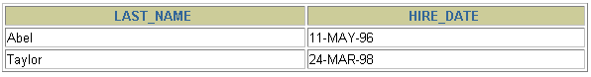
2. Create a report that displays the employee number, last name, and salary of all employees who earn more than the average salary. Sort the results in order of ascending salary.
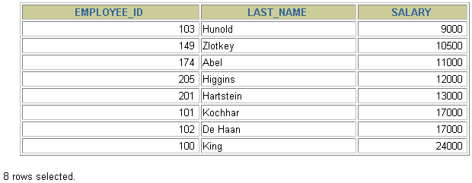
3. Write a query that displays the employee number and last name of all employees who work in a department with any employee whose last name contains a u.
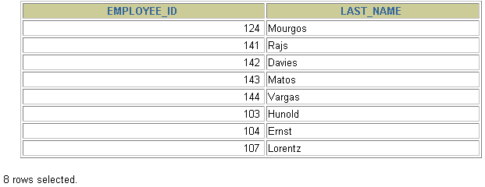
4. The HR department needs a report that displays the last name, department number, and job ID of all employees whose department location ID is 1700.
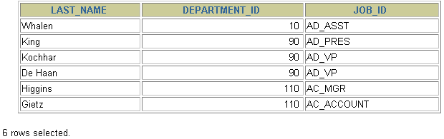
5. Create a report for HR that displays the last name and salary of every employee who reports to King.
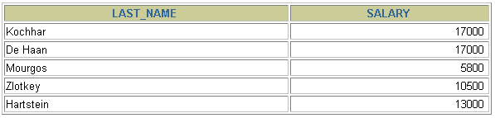
6. Create a report for HR that displays the department number, last name, and job ID for every employee in the Executive department.
